Name Bilal Abid Abbasi

Class 1 semester

Pf lab assignment

Iqra University
Islamabad Campus Fall Semester 2026

LAB TASK 8
Course Code: CSC 131 | Course Title: Programming Fundamental
Teacher’s Name: Mr. Ilyas Badshah | Total Marks: 10
Deadline: 10 Jan 2026 | Time: 11 59 pm

1. Numbers between 1 and 100 divisible by both 3 and 5

Program
#include <iostream>
using namespace std;

int main() {
for (int i = 1; i <= 100; i++) {
if (i % 3 == 0 && i % 5 == 0) {
cout << i << " ";
}
}
return 0;
}
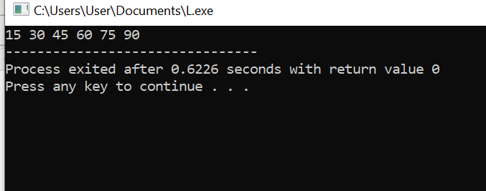

Output
15 30 45 60 75 90

2. Count vowels in a string (using for loop)

Program
#include <iostream>
using namespace std;

int main() {
string str;
int count = 0;

cout << "Enter a string: ";
getline(cin, str);

for (int i = 0; i < str. length(); i++) {
char ch = str[i];
if (ch == 'a' || ch == 'e' || ch == 'i' ||
ch == 'o' || ch == 'u' ||
ch == 'A' || ch == 'E' || ch == 'I' ||
ch == 'O' || ch == 'U') {
count++;
}
}

cout << "Number of vowels = " << count;
return 0;
}
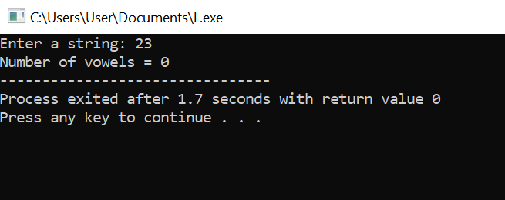

3. Find the largest number among N numbers

Program
#include <iostream>
using namespace std;

int main() {
int n, num, largest;

cout << "Enter the count of numbers: ";
cin >> n;

cout << "Enter " << n << " numbers: ";
cin >> largest; // first number as initial largest

for (int i = 1; i < n; i++) {
cin >> num;
if (num > largest) {
largest = num;
}
}

cout << "Largest number = " << largest;
return 0;
}
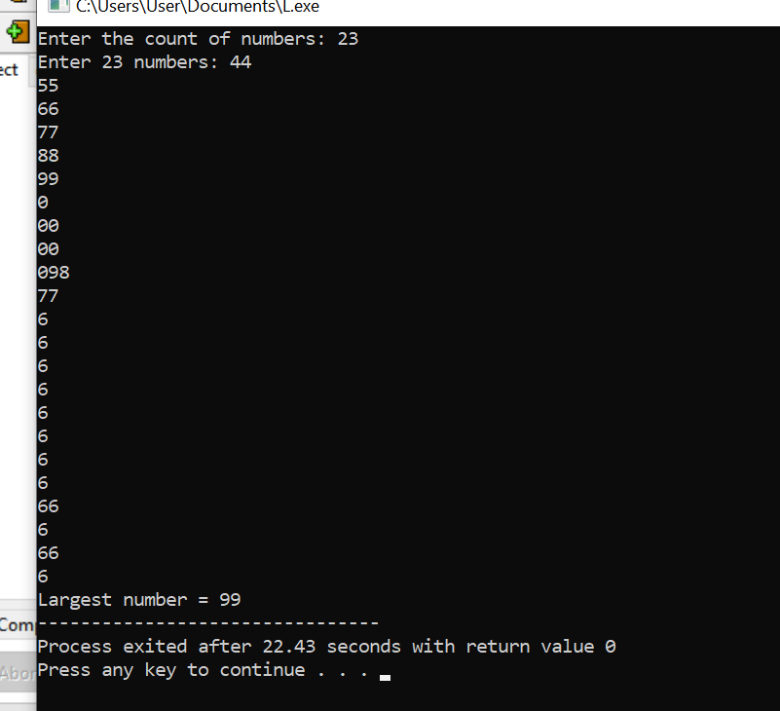

4. Sum of squares of first N natural numbers

Program
#include <iostream>
using namespace std;

int main() {
int n, sum = 0;

cout << "Enter a number: ";
cin >> n;

for (int i = 1; i <= n; i++) {
sum = sum + (i * i);
}

cout << "Sum of squares = " << sum;
return 0;
}
